**Procedure:-**

1.Download and Install Terraform and Setup Path

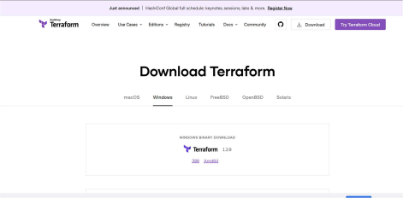2. After Installation Extract the folder C:\terraform_1.2.8_windows_amd64

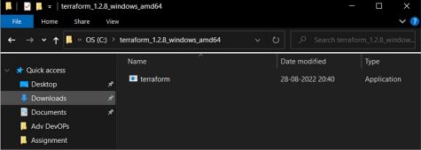

3.Edit Environment Variable Path

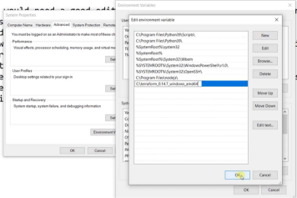4. Check the version installed in the system

>> terraform --version

